Chapter 16 questions
# 16.9
The one way anova for the given data is as shown -
Anova: Single Factor
SUMMARY
Groups | Count | Sum | Average | Variance
Zero | 3 | 15 | 5 | 4
Twenty-Four | 3 | 18 | 6 | 4
Forty-Eight | 3 | 12 | 4 | 4
ANOVA
Source of Variation | SS | df | MS | F | P-value | F crit
Between Groups | 6 | 2 | 3 | 0.75 | 0.512 | 5.14325285
Within Groups | 24 | 6 | 4
Total | 30 | 8

As the p-value for the F-test of equality of variance is greater than the significance level of 0.05, so DO NOT REJECT the null hypothesis and conclude that the mean score are not significantly different for different sleep hours.
16.11
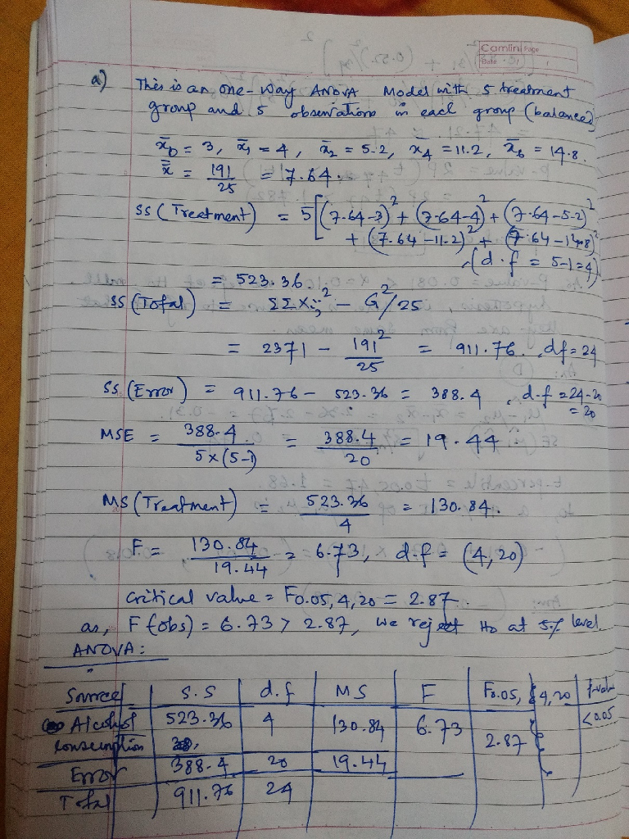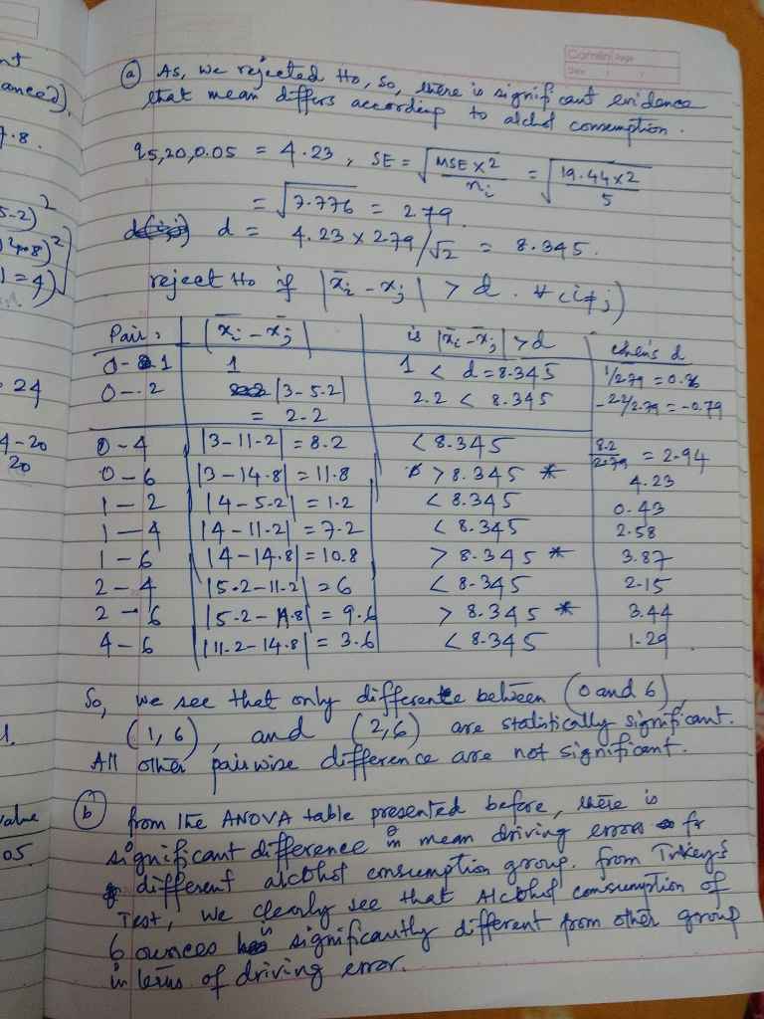c) I think the expression didn't get resolved. Estimate the effect size with 2 as it appears to me
16.13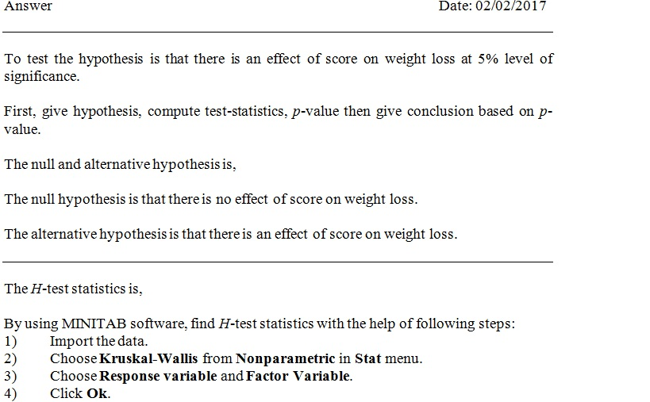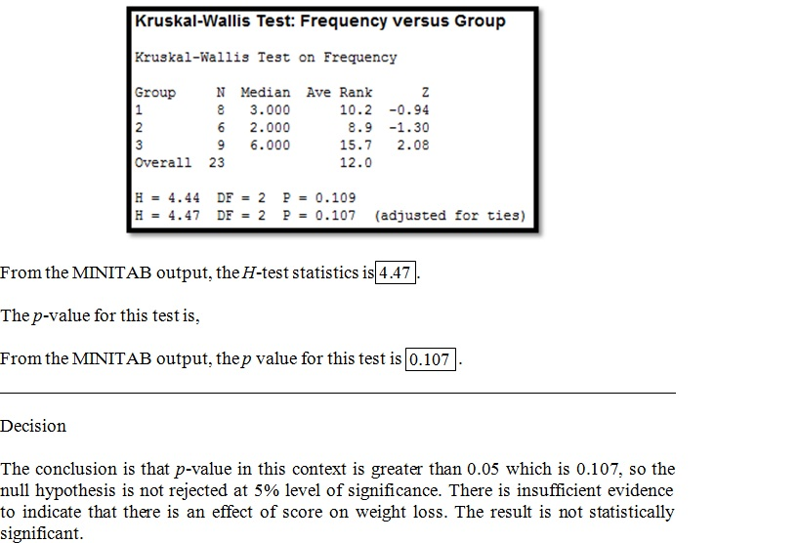
16.14.
Comparison of sources of variability is important. Similar to the F test which is useful for understanding the variances, the t-test is useful in understanding whether two independent groups can be viewed likewise for their means.

Chapter 19 questions
# 19.9
Level of significance.
Step 1) State H0 and H1:
H0: In the underlying population, crimes are equally likely to be committed on any day of the week.
Vs
H1: In the underlying population, crimes are not equally likely to be committed on any day of the week.
Step 2) Test statistic:
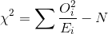
 | Oi Observed | Ei Expected | Oi^2/Ei
Mon | 17 | 20 | 14.45
Tue | 21 | 20 | 22.05
Wed | 22 | 20 | 24.2
Thu | 18 | 20 | 16.2
Fri | 23 | 20 | 26.45
Sat | 24 | 20 | 28.8
Sun | 15 | 20 | 11.25
 | N=140 |  | 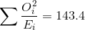
Thus
Step 3) Chi-square critical value:
df = k - 1 = 7 - 1 = 6
Right tail area= 0.01
From Chi-square critical value table:
Chi-square critical value = 16.812
P-value: Excel unction – CHISQ.DIST.RT (3.4, 6) = 0.7572
Step 4) Rejection Region:
Reject H0, if Chi-square test statistic value > Chi-square critical value, otherwise we fail to reject H0.
Since Chi-square test statistic value =3.400 < Chi-square critical value = 16.812, we fail to reject H0.
Step 5) Conclusion:
In the underlying population, crimes are equally likely to be committed on any day of the week.

19.11
Set Up Hypothesis
Null,that heads and tails are equally likely H0:P=0.5
Alternate, n't HO H1: P!=0.5
Test Statistic
No. Of Success chances Observed (x)=30
Number of objects in a sample provided(n)=50
No. Of Success Rate ( P )= x/n = 0.6
Success Probability ( Po )=0.5
Failure Probability ( Qo) = 0.5
we use Test Statistic (Z) for Single Proportion = P-Po/Sqrt(PoQo/n)
Zo=0.6-0.5/(Sqrt(0.25)/50)
Zo =1.4142
| Zo | =1.4142
Critical Value
The Value of |Z α| at LOS 0.05% is 1.96
We got |Zo| =1.414 & | Z α | =1.96
Make Decision
Hence Value of |Zo | < | Z α | and Here we Do not Reject Ho
P-Value: Two Tailed (double the one tail ) - Ha : ( P != 1.41421 ) = 0.1573
Hence Value of P0.05 < 0.1573, Here We Do not Reject Ho
We support that heads and tails are equally likely
19.12
reported weights ending in either a 0 or a 5 is 27
reported weights ending in 1, 2, 3, 4, 6, 7, 8, or 9 is 26
Let P: proportion of all weights should end in either a 0 or a 5
Ho: P=0.2
Ho: P?0.2
Goodness of Fit Test
 | observed | expected | O - E | (O - E)² / E
 | 27 | 10.600 | 16.400 | 25.374
 | 26 | 42.400 | -16.400 | 6.343
Total | 53 | 53.000 | 0.000 | 31.717
 | 31.717 | chi-square
 | 1 | df
 | 0.0000 | p-value
Critical chi square with df=1 is 3.841
Calculated chi square 31.717 which is > 3.841. Ho is rejected.
We conclude that weights are rounded to the nearest pound end in either a 0 or a 5.

19.16
The B and AB groups are combined here to have sufficiently large expected frequencies.
The observed and expected frequencies are then computed as:
Group | O | A | B or AB
Observed Frequency | 27 | 26 | 4 + 3 = 7
Expected Frequency | 0.44*60 = 26.4 | 0.41*60 = 24.6 | 0.15*60 = 9
Now the chi square test statistic for the test here is computed as:
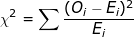
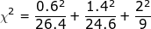
Now for n - 1 = 2 degrees of freedom, the p-value for this test for goodness of fit is computed form the chi square distribution tables as:
As the p-value here is 0.7642 > > 0.01 which is the level of significance, therefore the test is not significant and we cannot reject the null hypothesis here. Therefore we dont have sufficient evidence that the given data has different proportions.

19.17
To test :
H₀ : Gender and attitude towards gun control are independent of each other
vs.
H₁ : Gender and attitude towards gun control are dependent of each other .
Test statistic :
where , r : number of rows
c : number of columns
O_{i} : Observed frequency
E_{i} : expected frequency
Here , expected frequency can be calculated by the following formula
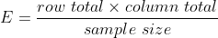
We reject H₀ if the observed value of , where ,
We can also reject or accept H₀ based on p-value .
If , then we reject H₀ , otherwise we accept H₀ .
The contingency table for the observed frequency is given below :
 | Attitude towards gun control | Favor | Oppose | Total
Gender
Male |  | 40 | 20 | 60
Female |  | 30 | 10 | 40
Total |  | 70 | 30 | 100
The contingency table for the expected frequency is given below :
 | Attitude towards gun control | Favor | Oppose | Total
Gender
Male |  | 42 | 18 | 60
Female |  | 28 | 12 | 40
Total |  | 70 | 30 | 100
Now, the observed value of
Degrees of freedom = ( 2 - 1 ) . ( 2 - 1 ) = 1
Now ,
Hence we accept the null hypothesis or H₀ .
Now , the p-value = 0.373 , hence we accept H₀ .
Conclusion
The gender of a person has no influence in his or her attitude towards gun control .

19.18.
Answer:
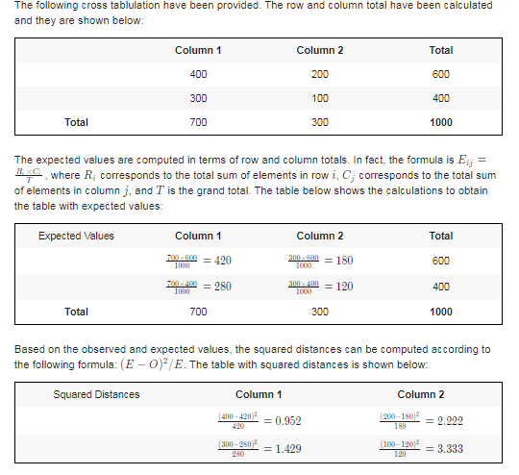
Null and Alternative Hypotheses
The following null and alternative hypotheses need to be tested:
H0​: The two variables gender and attitude toward gun control are independent
Ha​: The two variables gender and attitude toward gun control are dependent
This corresponds to a Chi-Square test of independence.
